

Project Report

**BLACKBOARD CLONE**

**Submitted By: Submitted To:**

Name: Simarpreet Singh Mr. Ankush Kapoor

UID: 20MCA1137

Batch/Sec: MCA/1B

**UNIVERSITY INSTITUTE OF COMPUTING**



**DECLARATION**

I Simarpreet Singh student of 3rd Semester MCA, Chandigarh University, Gharuan hereby declare that this activity was carried out be me and this report was prepared by me. Under the guidance of Mr. Ankush Kapoor.

Place : Gharuan

Date :

**CERTIFICATE OF ORIGINALITY**

This is to certify that the project report entitled **BLACKBORD (CLONE)**

Submitted to **University Institute of Computing, Chandigarh University** in partial fulfilment of the requirement for the award of the degree of **Master of Computer Applications**, is an authentic and original work carried out by Mr. / Ms. ______________ with enrolment No. _______________ under my guidance. The matter embodied in this project is genuine work done by the student and has not been submitted whether to the University or to any other University / Institute for the fulfilment of the requirements of any course or study.

Signature of the Student: Signature of the Guide:

Date: Date:

Name and Address of the Student: Name, Designation, Emp Id:

**ABSTRACT**

This report specify the various process and techniques used in gathering requirements, designing, implementing and testing for the project on learning management system. The problems regarding the current system in the college were analyzed and noted. This project aims to solve some of those problems and thus, add more value to the current system. The requirements were gathered from all the stakeholders and based on that we created a requirements models and designed the software based on the based. The project was implemented in the form of web application using MERN Stack.

Using the various resources and tools we gathered along the way, we implemented the learning management system with some additional features that solve the current problems in the system. The software was also tested using the various testing methods and results were positive.

Thus, the results can be integrated in current learning management system to improve its working and solve some of the existing problems.

**TABLE OF INDEX**

**CONTENTS:**

**TOPIC PAGE NO**

1. Introduction to the project 7-9
   1. Identification …..……………………………………………………………...
   2. Purpose ………………………………………………………………………..
   3. Scope ………………………………………………………………………….
   4. Overview and Restriction ……………………………………………………..
   5. Gapes in existing system ………………………………………………………
2. Overall Description 10-11
   1. Product Perspective …………………………………………………………...
   2. User Classes and Characteristics ……………………………………………...
   3. Features of the Project ………………………………………………………..
   4. Operating Environment ………………………………………………………
3. Proposed Methodology 12
4. Requirements 13
   1. Expected Requirement: Student and Staff information ……………………….
   2. Normal Requirement: Online Class ………..…………………………………
   3. Exciting Requirement: Communication among students and teachers ……….
5. External Interface Requirements 14
   1. User Interfaces ……………………………………………………………….
   2. Hardware Interfaces ………………………………………………………….
   3. Software Interfaces …………………………………………………………..
   4. Communications Interface …………………………………………………..
6. Non-functional Requirement 15
   1. Safety Requirements ………………………………………………………...
   2. Security Requirements ………………………………………………………
   3. Software Quality Attributes ………………………………………………….
7. Tools, Hardware and Software Specification 16
8. System Design 17-21
   1. Student ……………………………………………………………………….
   2. Teacher ……………………………………………………………………...
   3. Administrator ……………………………………………………………….
   4. Use Case Diagram ………………………………………………………….
   5. Class Diagram ………………………………………………………………
   6. Entity Relationship Diagram ……………………………………………….
9. Implementation Details 22
10. Modules in the system 23-24
    1. Student
       1. Login …………………………………………………………..
       2. Homepage ……………………………………………………..
       3. Course Detail ………………………………………………….
       4. Quiz and Assignment ………………………………………….
       5. Online Class …………………………………………………...
    2. Teacher
       1. Login ………………………………………………………….
       2. Homepage …………………………………………………….
       3. Course Detail …………………………………………………
       4. Upload Quiz and Assignment ………………………………..
       5. Online Class ………………………………………………….
    3. Administrator
11. Screenshots of the implemented system 25-33
12. Conclusion and future work 34
13. References 35
14. Plagiarism 36
15. **INTRODUCTION**

Blackboard learning management system is the virtual learning environment developed by Blackboard Inc. It is a Web app that has the feature of course management and video communication. With Blackboard learn, universities, businesses, and schools can provide quality education to their students. ELearning technology has changed the way of teaching and learning. Blackboard learn having the functionality to track our progress. Now having access to our virtual classrooms from any internet-accessed device because of this web application.

* 1. **Identification**

The software system being considered for the development is referred to as Learning Management System. The ultimate end-users, of the system will be Teachers and the HODs of each department in University, Students and Administrators. This is a new project sort, so the version under development is version 1.0.

* 1. **Purpose**

The purpose is to design software for make e-learning more efficient. Blackboard (clone) consists of different modules such as student, faculty, admin etc. Our main purpose is to create a software which will manage the working of these different modules. This interconnectivity among modules reduces the time to perform different operational tasks.

* 1. **Scope**

Learning Management System is becoming a very essential component in education in this modern day age. With the help of Blackboard (clone) we can attend classes online from our browser in few clicks. Once the details are fed into the database there is no need for various persons to deal with separate sections.

* 1. **Overview and Restriction**

This document is for limited release only to personnel working on the project and the project mentors and reviewers.

**Chapter 2** of this document describes the system under development from a holistic point of view. Functions, characteristics, constraints, assumptions, dependencies, and overall requirements are defined from the system level perspective.

**Chapter 3** of this document describes the interfaces of the system being developed. They impose guidelines on the design of the product being developed.

**Chapter 4** of this document describes the Functional Requirements of the system being developed. Functional Requirements are categorized on the basis of System Features. They are enumerated and described to a degree sufficient for a knowledgeable designer or coder begin crafting an architectural solution to the proposed system.

**Chapter 5** of this document describes the Non Functional Requirements of the system being developed. They are critical for the working for the system. Designer and implementers should make sure that all the Non Functional Requirements are satisfied.

**Appendix a** covers the Glossary, which defines some abbreviations and terms used in document, which are not covered in introduction.

**Appendix b** includes all reference models such as Schema Diagram. Designers can refer Appendix b and craft the software accordingly.

* 1. **GAPES IN EXISTING SYSTEM**

The gaps regarding the Existing system were analyzed and noted. This project aims to solve some of those gaps and thus, add more value to the existing system. The major gap in the existing system is the speed with the help of react JS we can make it even faster and also applying a NoSQL database to increase the data fetching speed. The project was implemented in the form of a web app using React JS, Node JS, and Express JS.

1. **Overall Description**
   1. **Product Perspective**

It is made after extensive study of all the departments like student, faculty, etc. of colleges and is provided with the extract of everything a college requires for e-learning. The security issue within LMS has been there for a long time, but most of the solutions based on the assumption that an LMS system is a closed environment. The need to evaluate their benefits and impacts on organizations and individuals are increasingly essential.

* 1. **User Classes and Characteristics**

There are several types of end users for the LMS system. They are broadly divided as Students, Staff and the Administrator. Each of these classes have their own set of features.

* The student should have the following features:
* View the enrolled Courses and their description.
* View the marks of attempted quiz.
* Join the online class.
* View the notification from the courses.
* View own profile details.
* The staff should have the following features:
* Access to the information of courses.
* Start online class.
* Upload Assignments and Quizzes.
* The administrator should have the following features:
* Add students, teachers and courses.
* Assign teachers and students to courses.
  1. **Features of the Project**

A piece ofsoftwareis feature-rich when it has many options and functional capabilities available to the user. There are some of the features of the project are:

* + 1. **Speed:** The loading speed of a web app is more important today. So I recreated blackboard learn with React JS as the front-end of my application and MongoDB for the database. The login and data fetching speed are increments.
    2. **URL Routing:** Routingis the process in which a user is directed to different pages on their actions and request. I used React Router to make routing even faster in my project and the reloading time of a web page is also decreased.
  1. **Operating Environment**

The operating environment for Learning Management System are listed below:

* Operating System : Windows 10
* Database : MongoDB
* Front-end : HTML/CSS/React JS/Material UI
* Back-end : Node.js/Express.js

1. **Proposed Methodology**

LMS means the techniques and concepts for learning management of education as a whole, from the viewpoint of effective use of management resources to improve the efficiency and quality of education. A fully integrated Web Application-based LMS can access from any internet-enabled device.

It was made after extensive study of all the departments like a student, teachers, etc. of the universities and provided with the extract of everything an educational institute required for online learning.

1. **Requirements**
   1. **Expected Requirement: Student and Staff information**

Description and priority information regarding students, teachers and courses are stored in the database. Every user can view only certain information based on their user class. For example, a teacher can upload quiz and assignments and students only can perform that.

**Functional Requirement:**

* Each user shall be able to view information in the database based on their user class.
* The administrator shall be able to view all the information in the database.
  1. **Normal Requirement: Online Class**

Description and priority creating and joining class is the main feature of the Learning Management System. Hence the priority is high. Teachers create classes for their corresponding course. Students can join the class.

**Functional Requirement:**

* Teachers can create class for their course.
* Student can join those class.
  1. **Exciting Requirement: Commutation among students and teachers**

Description and priority Students and Teachers will be able to communicate with each other directly using LMS. Students may give their queries and feedback to a teacher and they may respond accordingly. The priority of this feature is low as cost of implementation could be very high. A simple version of feature is to be implemented.

**Functional Requirement:**

* Students shall be able to communicate with their teachers by sends personal mails.

1. **External Interface Requirements**
   1. **User Interface**

The user interface is made using HTML, CSS, Material UI, and Bootstrap. Firstly, there will be a simple login page for students and teachers. There will a fixed slide-bar with links to all the modules.

* 1. **Hardware Requirement**

Since neither the mobile application nor the web portal have any designated hardware, it does not have any direct hardware interfaces. Any browser can be used to access the web application.

* 1. **Software Interfaces**

The following is a list of software used in making of the project:

* Operating System: I have chosen Windows operating system for its best support and user-friendliness.
* Postman: I have chosen postman to post dummy data into the database.
* Node.js: I have chosen to use Node.js for the back-end of the web application as I used React JS for that Node.js will be the perfect choice and suitable for this project.
* Database: I am using Mongo DB.
  1. **Communication Interfaces**

This project is to be deployed an online web application. All the users can connect to the database server from anywhere and have access to their information.

1. **Non-functional Requirements**
   1. **Safety Requirements**

If there is extensive damage to a wide portion of the database due to catastrophic failure, such as a disk crash, the recovery method a past copy of the database that was backed up.

* 1. **Security Requirements**

The database contains sensitive information of all the students and staff. Therefore, optimal security measures must be taken to ensure data is safe from unauthorized users.

* 1. **Software Quality Attributes**
* Availability: The users must always be able to view their information so they can keep track regularly.
* Correctness: The information about courses must be correct to not feed wrong information to the users.
* Portability: The users access the LMS from various platforms such as desktops and mobile phones. The web application must be portable to all platforms and the user experience must be optimal.

1. **TOOLS, HARDWARE AND SOFTWARE SPECIFICATION**

**Hardware Specification:**

**﻿**

1. Processor: 15 10th gen
2. RAM: 12GB DDR4
3. Storage: 512GB SSD & 1TB HDD
4. Graphics: 2GB UHD Graphics & 4 GB NVidia GTX1650ti

**Software Specification:**

1. Visual Studio Code: An code editor by Microsoft
2. Node.js: It's runtime chrome's V8 JavaScript Engine
3. MongoDB Compass: GUI based software to access MongoDB Atlas
4. Postman: It is an API platform for developing and testing forms by making different requests like GET, POST, etc.
5. NPM: It is a package manager to install packages from the web and include them in our project.
6. **System Design**

Various Design concepts and processes were applied to this project. Following concepts like separation of concerns, the software is divided into individual modules that are functionally independent and incorporates information hiding. The software is divided into 3 modules which are students, teachers and administrators. We shall look at each module in detail.

* 1. **Student**

Each student belongs to a class identified by semester and section. The students are given a unique User-ID and Password to login.

**Student Information:**

Each student can view only their own personal information. This includes their personal details like name, phone number, and address etc. Also, they can view the courses they are enrolled.

**Quiz and Assignments:**

Each student can view quiz and assignment given by the teacher and attempt that.

**Online Class:**

Students can view classes and join them according to the time table.

* 1. **Teacher**

Each teacher are assigned to classes with a course. Teachers will also have User-ID and Password for login. The different views for teachers are described below.

**Information:**

The teachers will have access to information regarding the courses and classes they are assigned to.

**Online Class:**

Teacher can create Class to join for students of their courses.

* 1. **Administrator**

The administrator will have access to all the information in the database. They will access to all the users information. They will be able to add entry in database.

* 1. **Use Case Diagram**

A use case diagram at its simplest is a representation of a user’s interaction with the system that shows the relationship between the user and the different use cases in which the user is involved. A use case diagram can identify the different types of users of a system and the different use cases and will often be accompanied by other types of diagrams as well.

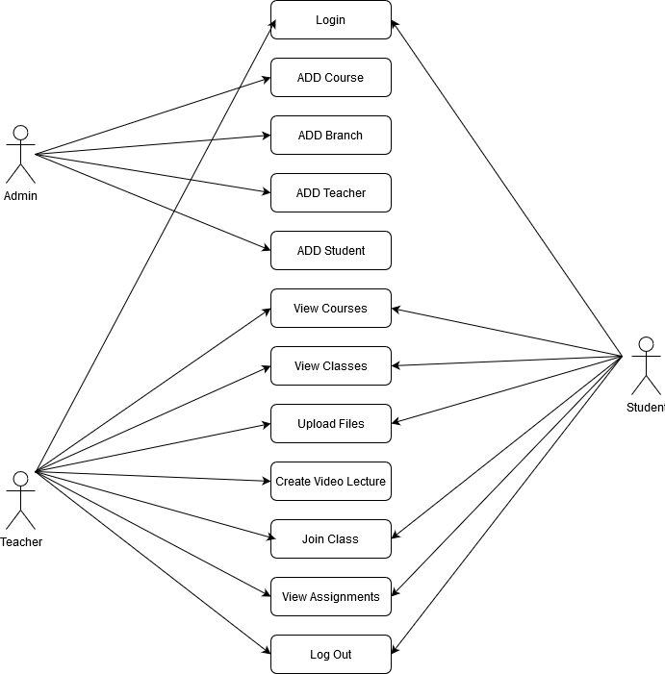

Figure 1: Use Case Diagram of LMS

* 1. **Class Diagram**

The class diagram states the different classes involved in the software. For each class, a set of attributes and method are included. The relationship between the classes are also specified.

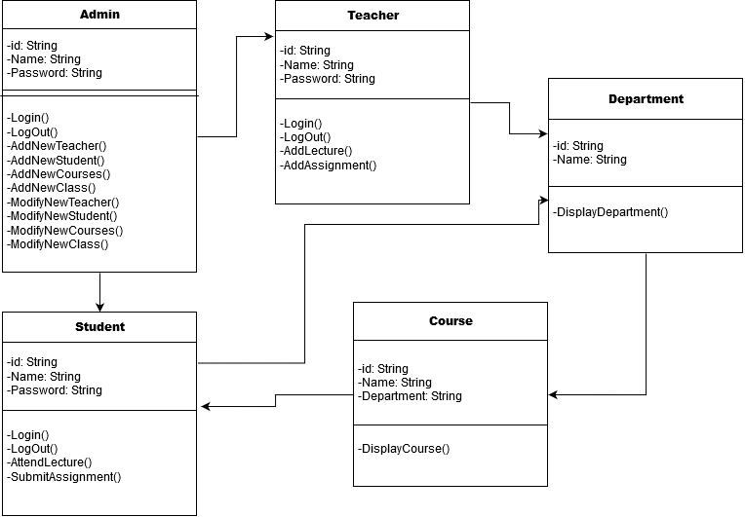

Figure 2: Class Diagram of LMS

* 1. **Entity Relationship Diagram**

An entity relationship diagram (ERD) shows the relationships of entity sets sorted in a database. An entity in this context is an object, a component of data. An entity set is a collection of similar entities.

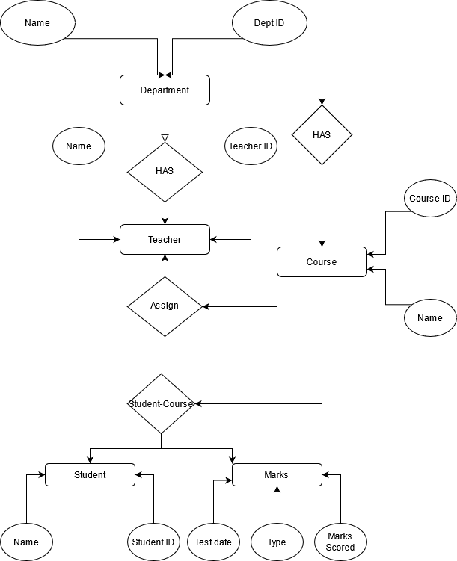

Figure 3: Entity Relationship Diagram

1. **Implementation Details**

The architecture comprises of various modules as given in the figure. There are 3 major categories in which the whole architecture in divided. These are administrator, teacher and student. The architecture is design such a way that is self-explanatory.

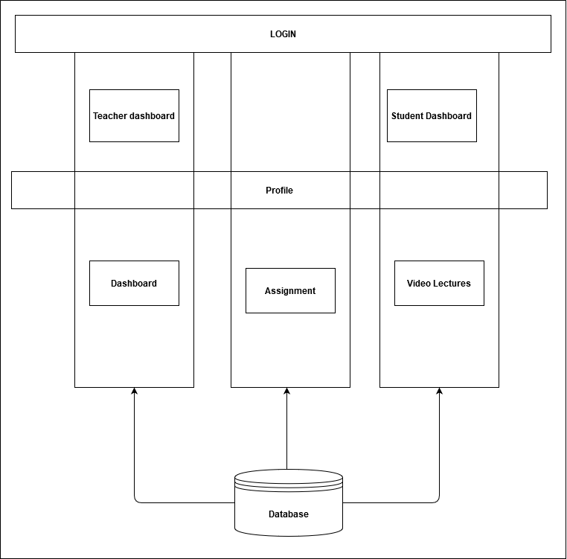

Figure 4: Architecture

1. **Modules in the system**

The Learning Management System has three main user classes. These include the students, teachers and administrator. This section will explain in detail all the features and the working of those for each user class.

* 1. **Student**
     1. **Login**

Each student in the college is assigned a User-ID and Password by the administrator. They can use there ID and Password for login.

* + 1. **Homepage**

After successful login, the student is presented a homepage with their courses section. There is navbar where all the components link are present for the students.

* + 1. **Course Detail**

When student click on any of the course they redirected to course details where they found different component of that section.

* + 1. **Quiz and Assignments**

In the course detail there is an option for give quiz of that subject when the student click on the start quiz they redirected to the quiz section after completing quiz they press submit to save there marks.

* + 1. **Online Class**

In the course detail there is an option for join the class created by teacher, When the student join the class they redirected to Class section where they ask to give camera and microphone permission to the browser in order to share their video and voice.

* 1. **Teacher**
     1. **Login**

Each student in the college is assigned a User-ID and Password by the administrator. They can use there ID and Password for login.

* + 1. **Homepage**

After successful login, the teacher is presented a homepage with their courses section. There is navbar where all the components link are present for the teachers.

* + 1. **Course Detail**

When student click on any of the course they redirected to course details where they found different component of that section.

* + 1. **Quiz and Assignments**

In the course detail there is an option for upload assignment for the students and also can create a quiz.

* + 1. **Online Class**

In the course detail there is an option for create class for students, When the teacher create and join the class they redirected to Class section where they ask to give camera and microphone permission to the browser in order to share their video and voice.

* 1. **Administrator**

The administrator is responsible for adding and maintaining all the courses, students, and teachers. All this data is stored in the database. The admin can view all the details present in the database.

1. **Screenshots of the implemented system**

**Project Structure:**

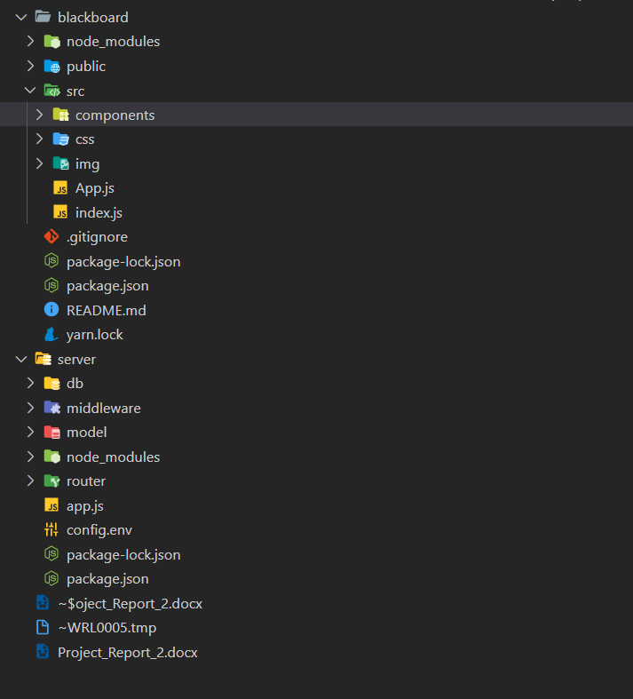

Figure 5: PROJECT STRUCTURE

**USER SCHEMA:**

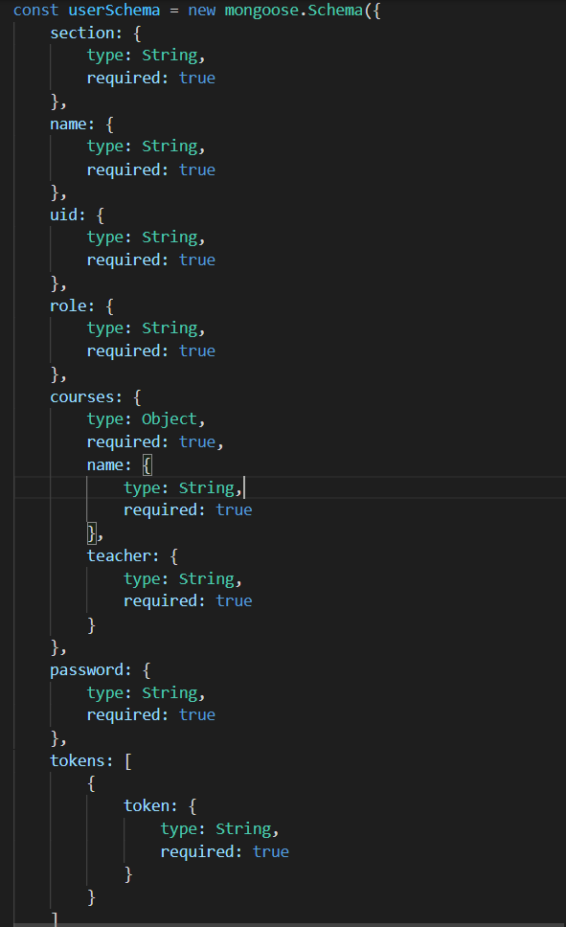

Figure 6: USER SCHEMA

**App.js**

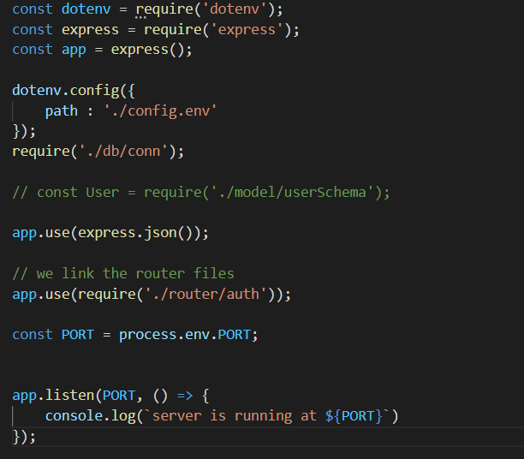

Figure 8: APP.js

**MIDDLEWARE**

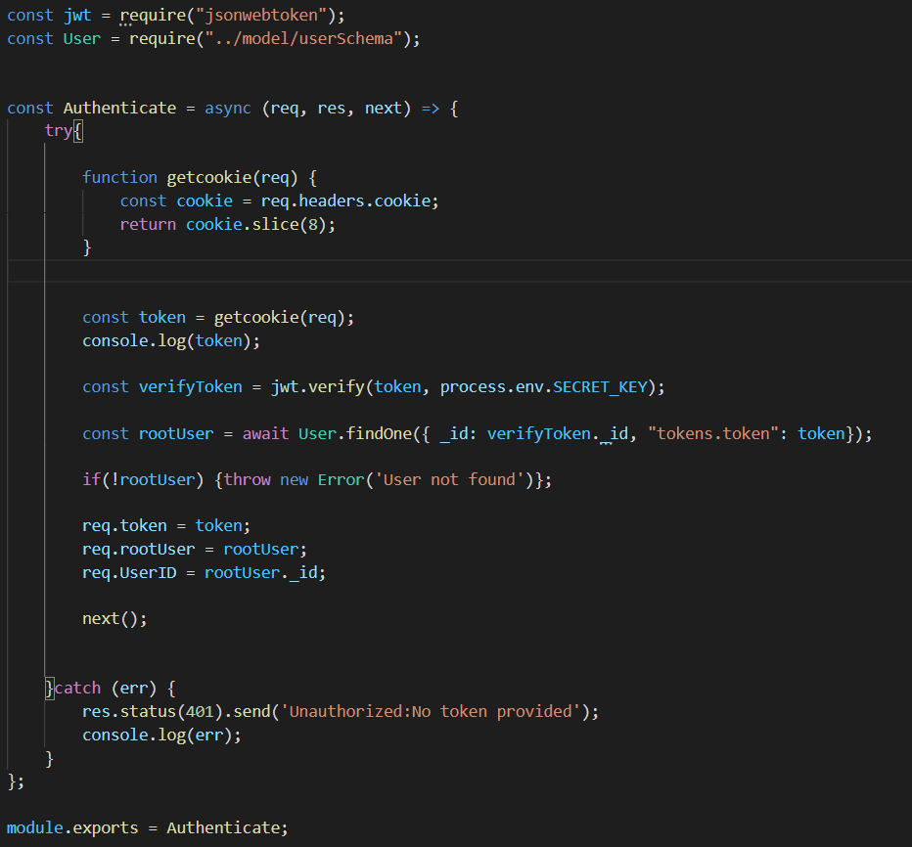

Figure 9: MIDDLEWARE

**USERAUTH**

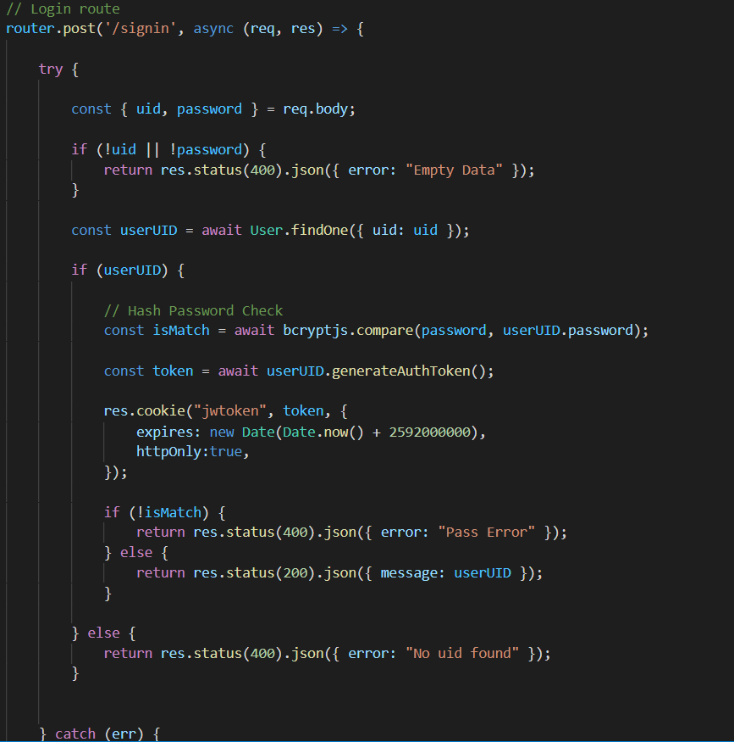

Figure 10: USERAUTH

**LOGIN SCREEN:**

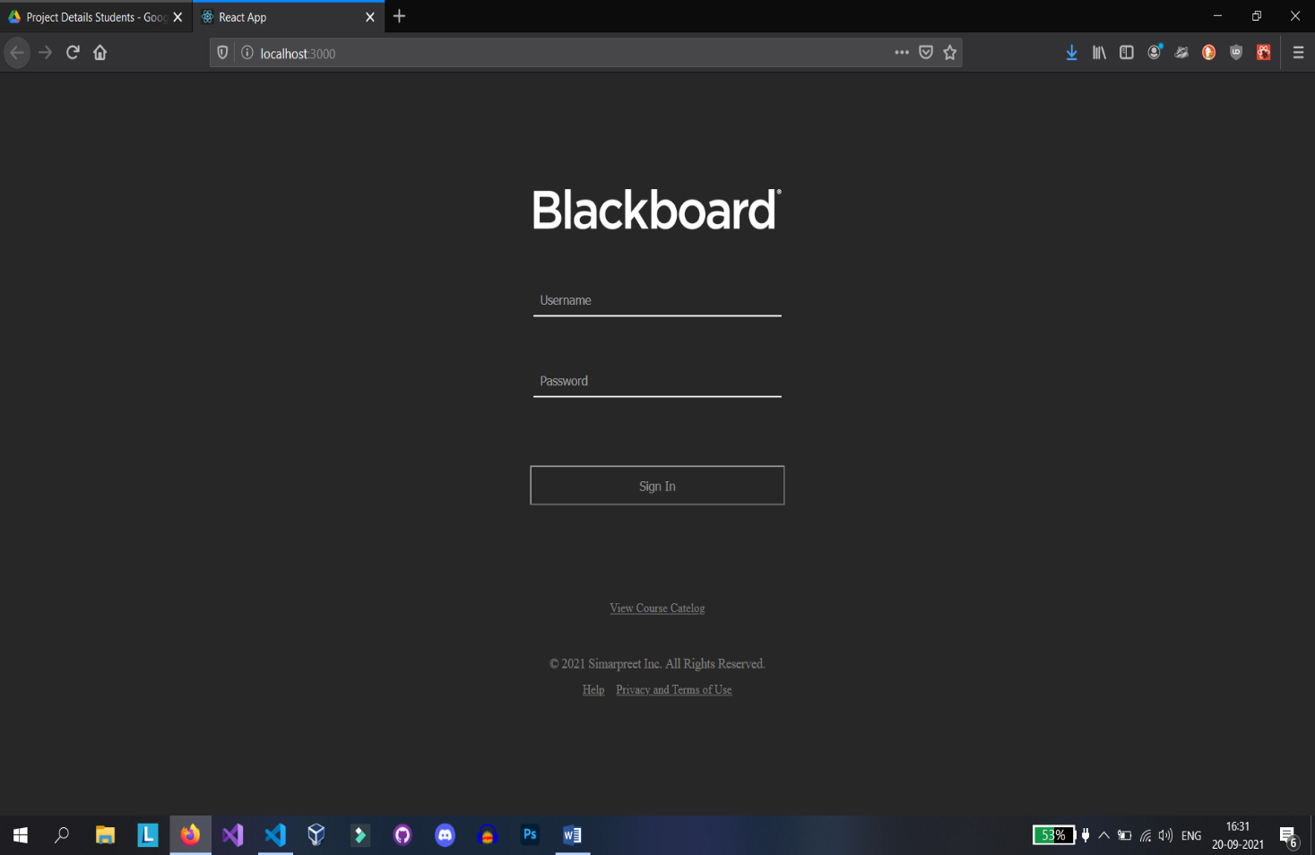

Figure 11: LOGIN SCREEN

**COURSES SCREEN:**

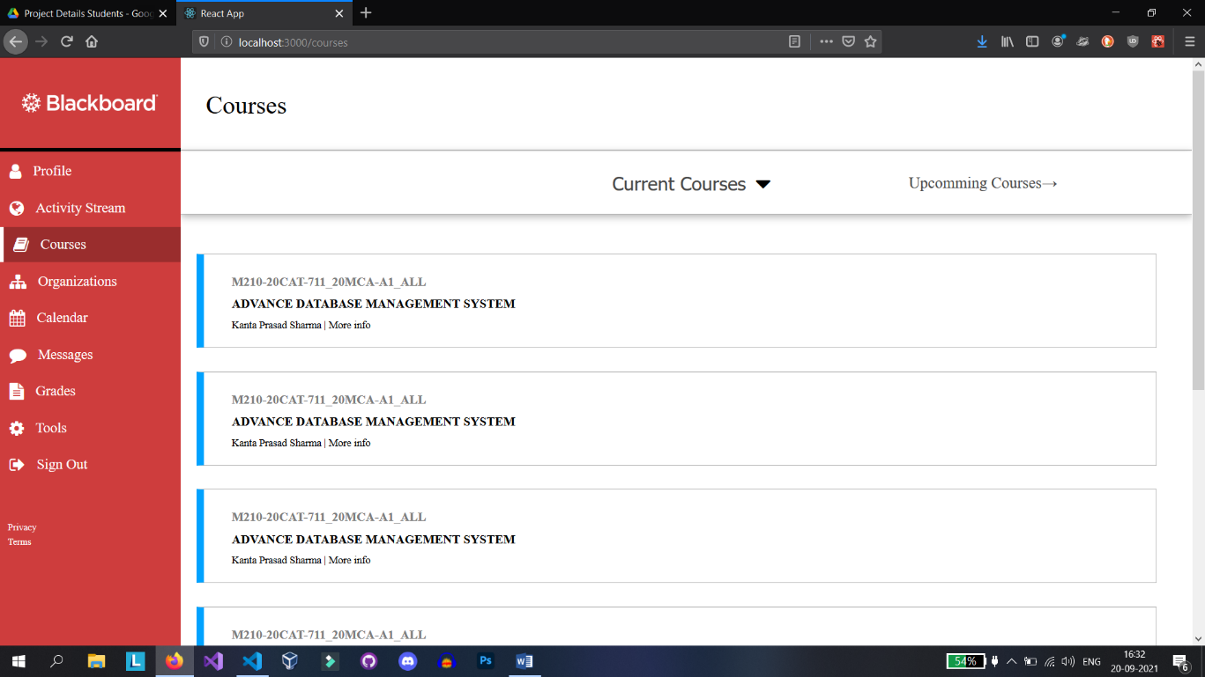

Figure 12: COURSES SCREEN

**ACTIVITY STREAM SCREEN:**

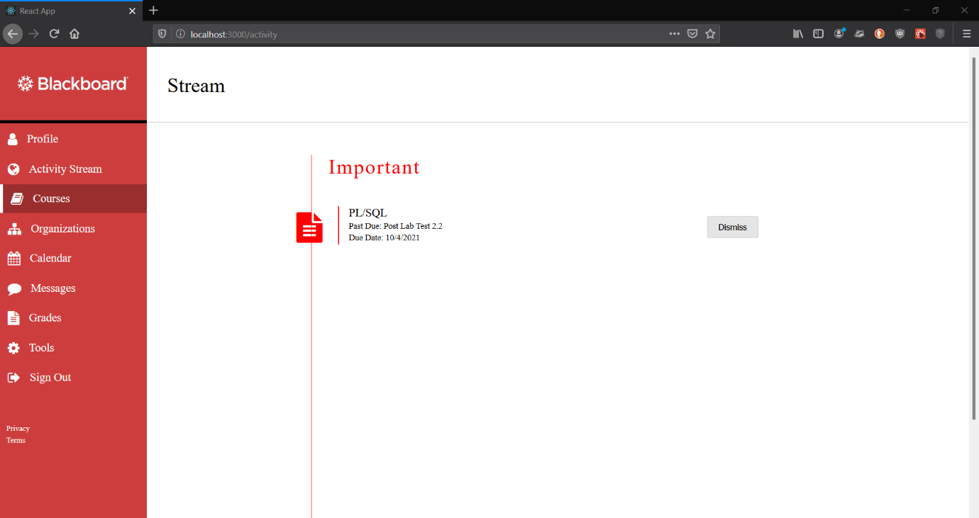

Figure 13: ACTIVITY STREAM SCREEN

**PROFILE SCREEN:**

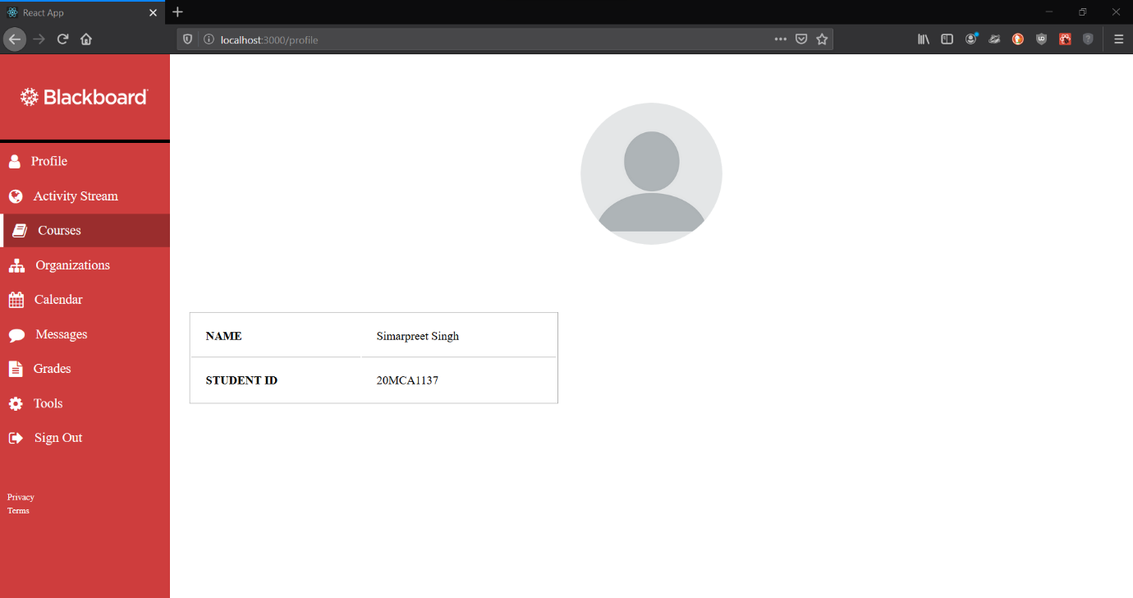

Figure 14: PROFILE SCREEN

**COURSE DETAIL**

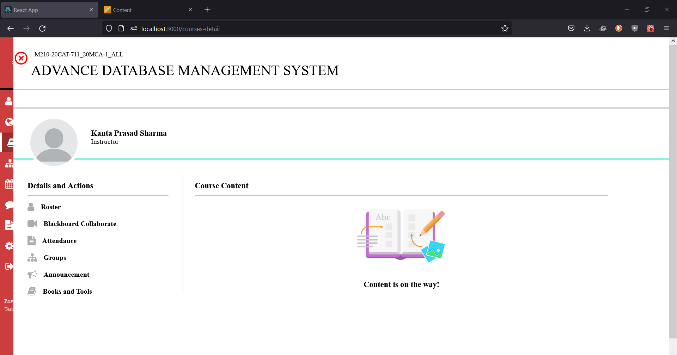

Figure 15: COURSE DETAIL

**JOIN CLASS**

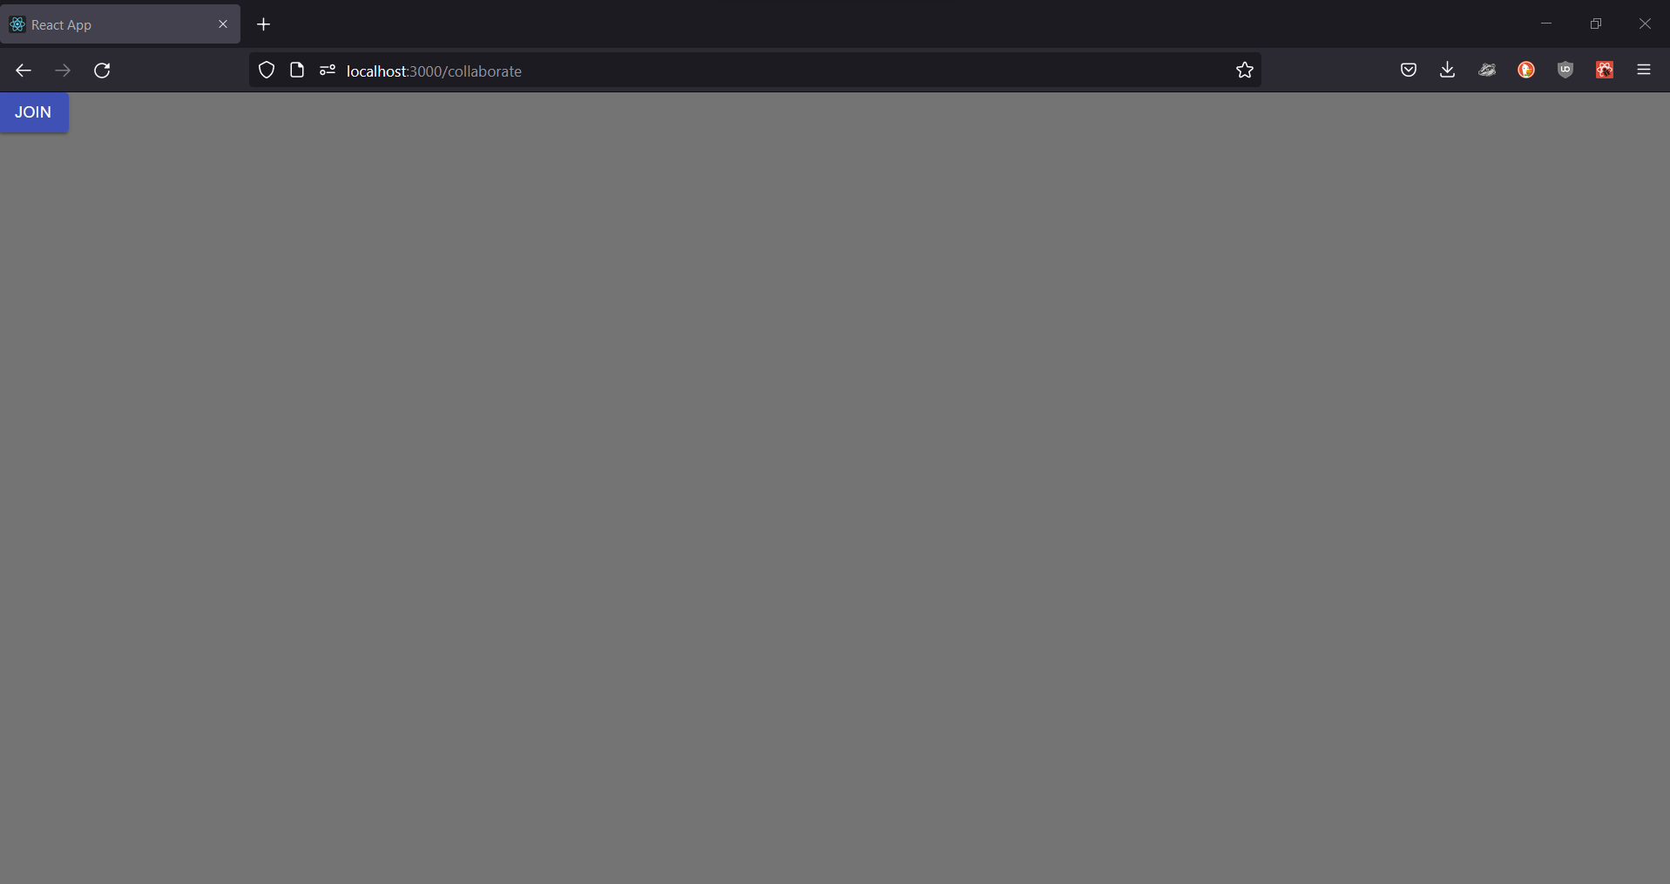

Figure 16: CREATE/JOIN CLASS

**ONLINE CLASS**

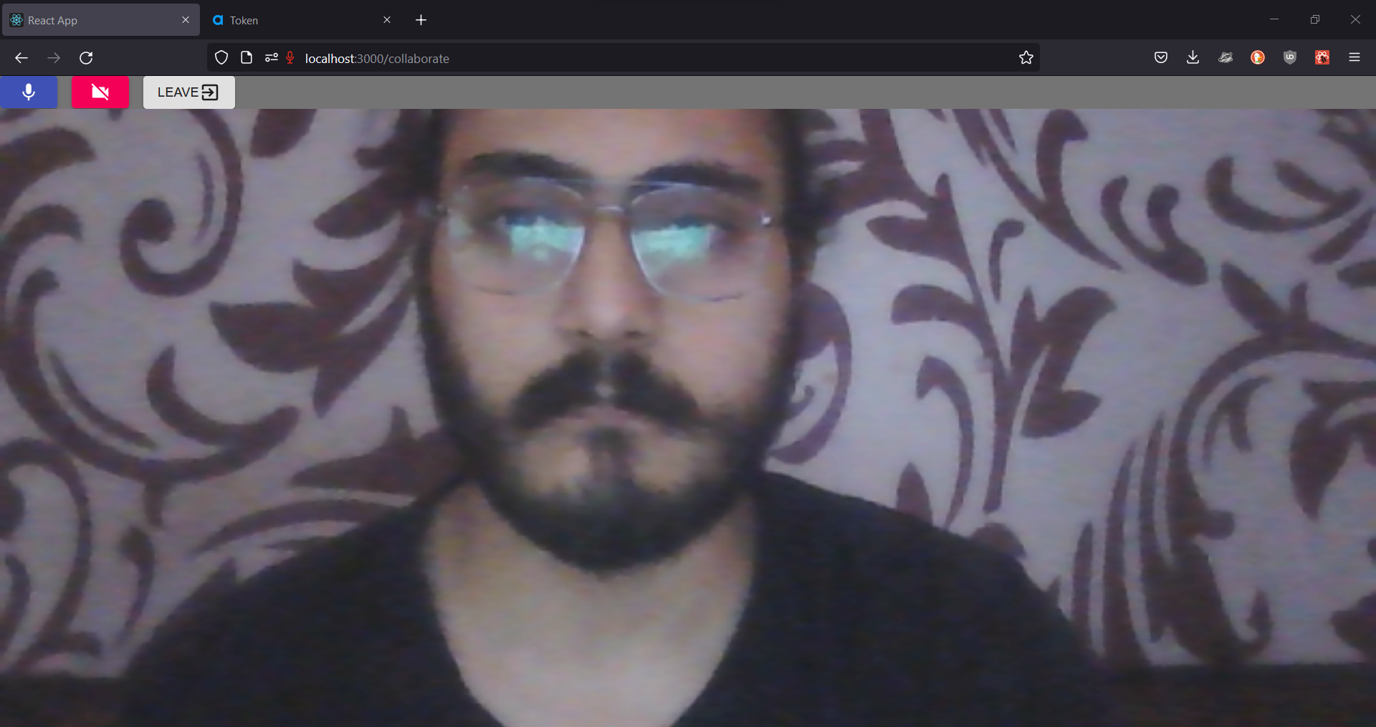

Figure 17: ONLINE CLASS

**GOUP ONLINE CLASS**

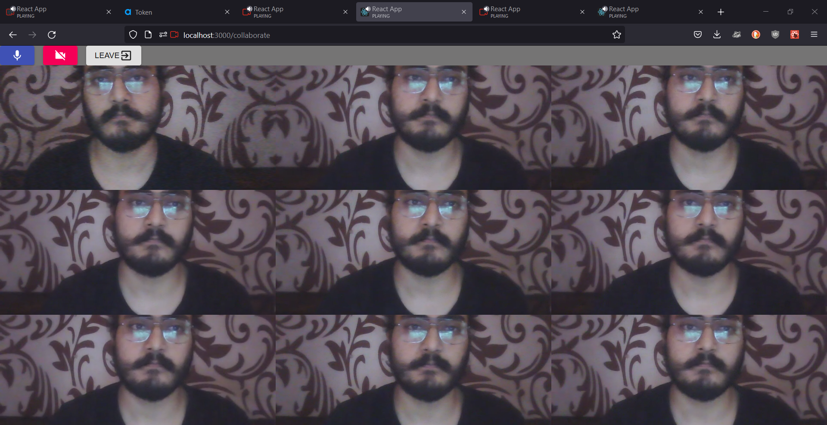

Figure 18: GROUP ONLINE CLASS

1. **Conclusion and Future Work**

By using Existing System accessing information from les is a difficult task and there no quick and easy way to see all the information regarding enrolled courses. Lack of automation is also there in the Existing System. The aim of Our System is to reduce the workload and to save significant staff time.

Title of the project as LMS System is the system that deals with the issues related to a particular institution during this pandemic. It is the very useful to the student as well as the faculties to easy access to the classroom. The LMS provides appropriate information to users based on their profiles and role in the system. This project is designed to make e-learning easier.

The fundamental problem in maintaining and managing the work by the administrator is hence overcome. But by developing this web-based application the administrator can enjoy the task, doing it ease and also by saving the valuable time. The amount of time consumption is reduced and also the manual calculations are omitted. The effective utilization of the work, by proper sharing it and by providing the accurate results. The storage facility will ease the job of the operator. Thus the system developed will be helpful to the administrator by easing his/her task.

This System provide the E-learning platform. It can be monitored and controlled remotely. It reduces the man power required. It provides great education that we can access from anywhere. The data which is stored in the repository helps in taking intelligent decisions by the management providing the accurate results. The storage facility will ease the job of the operator. Thus the system developed will be helpful to the administrator by easing his/her task providing the accurate results. The storage facility will ease the job of the operator.

This project is successfully implemented with all the features and modules of the Learning Management System as per requirements.

1. **References**
2. <https://reactjs.org/docs/getting-started.html>
3. <https://developer.mozilla.org/en-US/docs/Web/javascript>
4. <https://docs.mongodb.com/manual/core/document/>
5. <https://docs.npmjs.com/>
6. <https://react-bootstrap.github.io/>
7. <https://www.youtube.com/>
8. <https://stackoverflow.com/>
9. **Plagiarism**

